Vytality Fitness

Greg Bastien

Hung Nguyen

Florida Atlantic University

Abstract

Vytality Fitness is an app designed to assist people. We designed this app in hopes of battling against obesity, reducing heart diseases, and helping society live a healthier lifestyle. We used a variety of methods and languages to create this app such as JavaScript, html, and CSS. The first step we took was making the layout of the app. You’ll soon see below how our app was developed and the end result of our hard work.

Obesity is a preventable disorder. Being obese means that you are in a condition of being overweight. We determine obesity with the help of body mass index or BMI. We implanted the formula to find BMI into our app. All we require you to do is to enter your weight and height. After doing so, we determine if your weight is healthy, overweight, or obese depending on result of your BMI. If you fall within the range of 18 to 24, then you are considered to be in healthy weight range. If you fall between 25 to 29, then you are considered overweight. 30 and over is considered to be obese. Obesity is a dangerous disorder that can lead to heart diseases, unhealthy lifestyle, or even death. We have designed our app to help determine your BMI, give you advice about how to improve your lifestyle, and provide you with a graph on your progress towards being healthy.

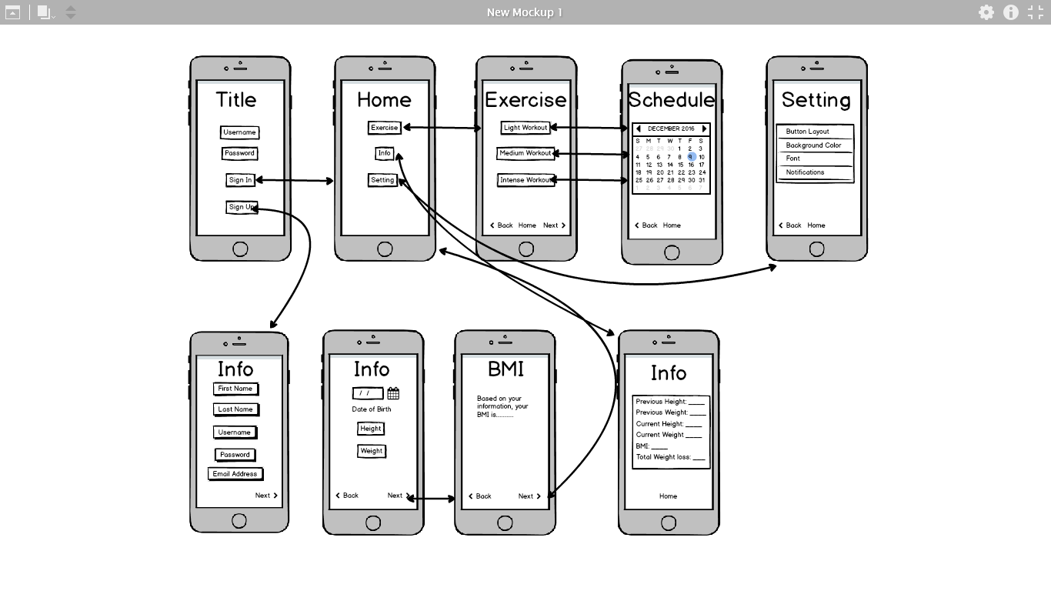

As you can see from the picture above, we started off with a simple layout of the app. First, we determined what key components our app would feature. Then we began designing each screen for those components. We used Balsamiq to make our layout. We used html, css, JavaScript, jQuery mobile, canvas, and MongoDB to build our app. We started with the login screen and then branched off from there. Next, we made the dashboard for easy navigation for the user. We made a page for giving nutritional information about food the user enters. We made a page for exercises our app provides for the user. There is also a page that calculates the user’s BMI. Lastly, we made a settings page to allow the user to customize certain parts of the app to their liking. Overall, we tried to make our app as simple as possible for easy use. Next, we will show how our app works before and after user input.

As you look at the picture below, you’ll the sign up page. This is how it looks before any user input.

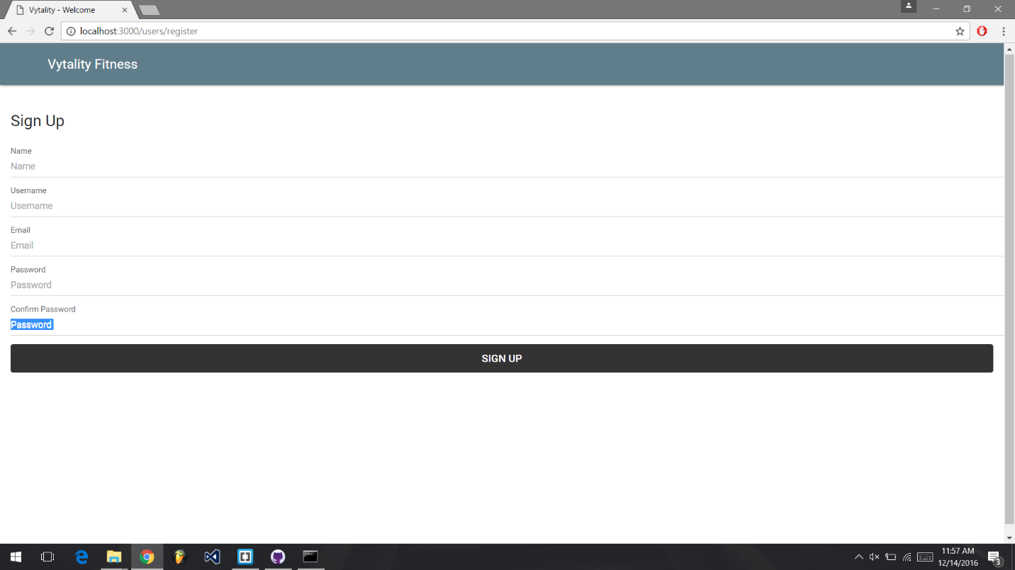

This next picture shows the login page after the user has made an account. This is how it looks before any user input.

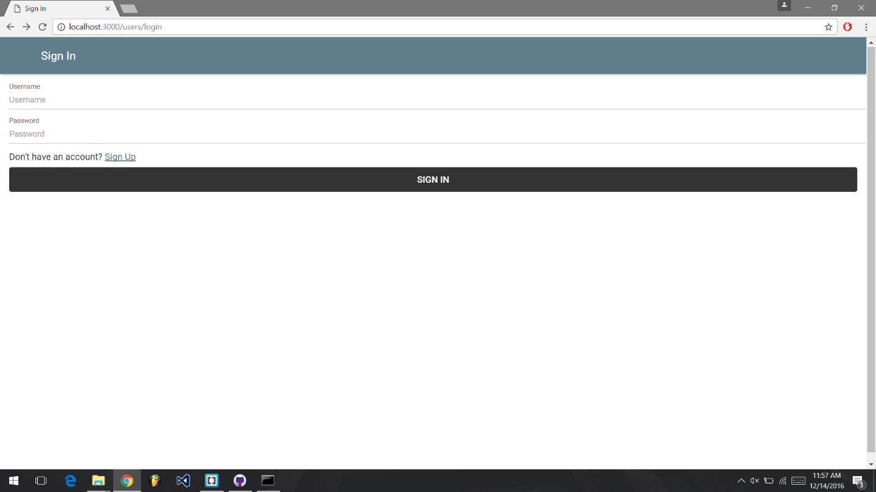

After user input, the app takes asks the user to the dashboard where they can select three pages to view. One of those pages is the exercise suggestion page.

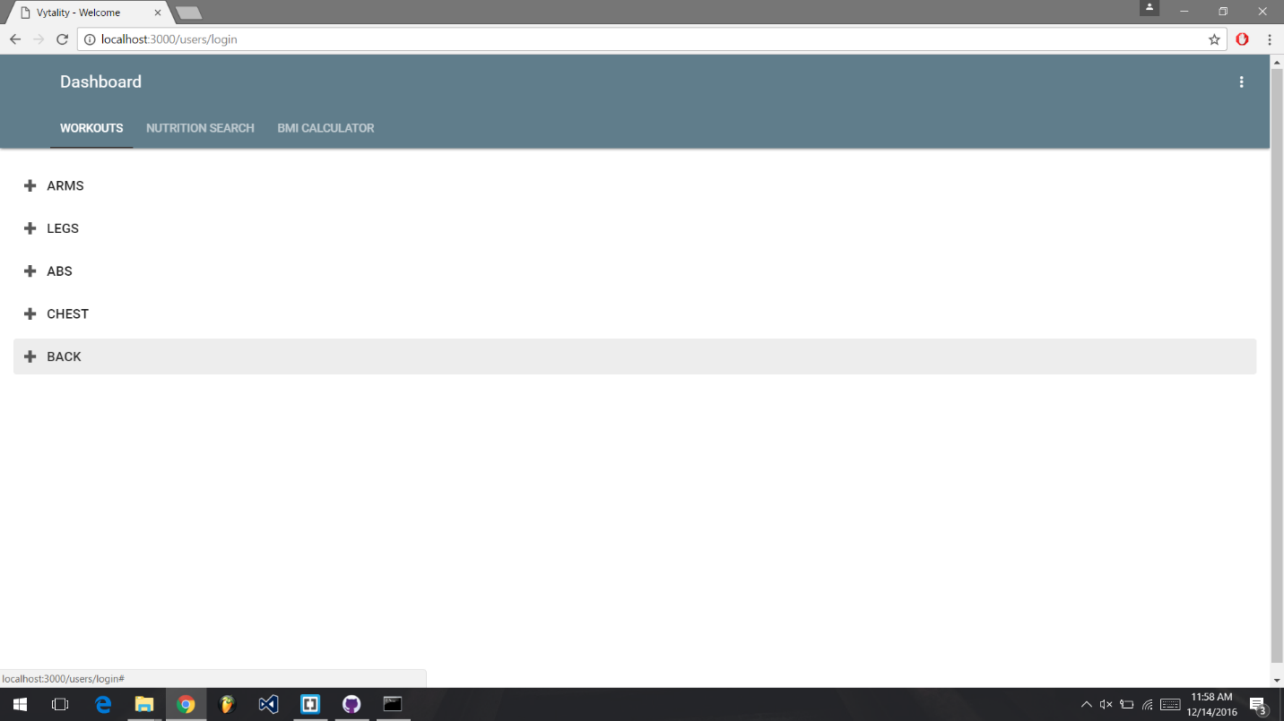

Another page the user can view is the nutrition page. Here, the user can type in a food and our app will give them information about that food.

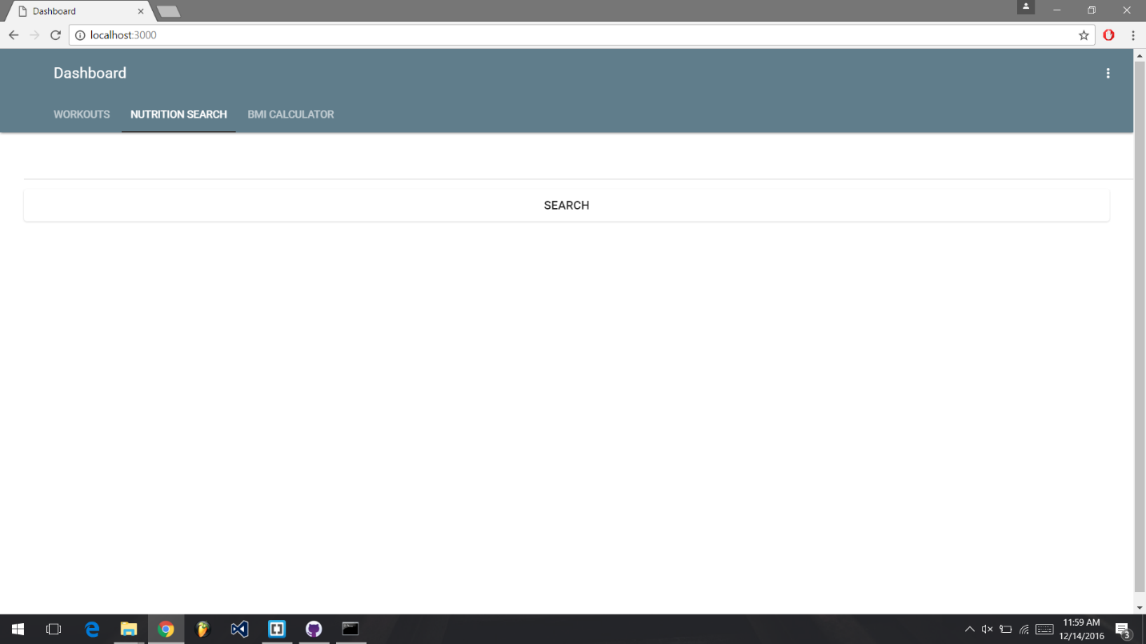

The last tab calculates the user’s BMI. This pictures shows an example of how BMI is calculated.

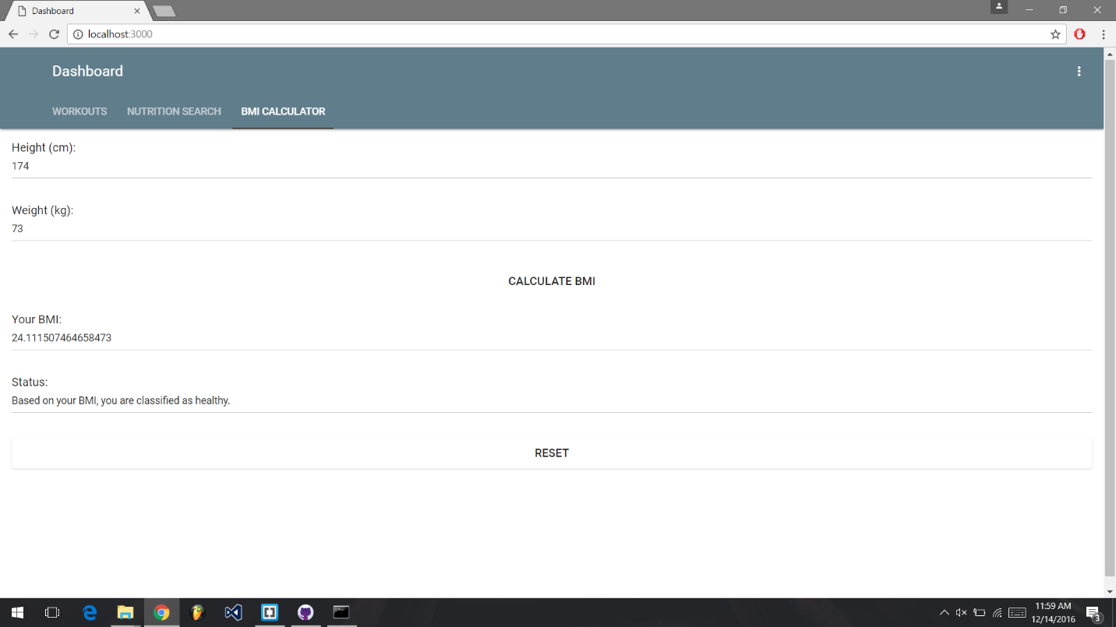

We started this app with the idea of how to get people to manage their health. Obesity is a serious disorder. It leads to heart disease and death. The United States has the most serious problem with obesity. It has the highest rate in the world. We hope that our app helps stop obesity and reduces heart disease.

Reference

Pawan, L. (2016). *Building Cross-Platform Mobile and Web Apps for Engineers and Scientists An Active Learning Approach*. Boston: Cengage Learning. (2016, October 18).

American Heart Association - Building healthier lives, free of cardiovascular diseases and stroke.. *Obesity Information.*Retrieved December 1, 2016, from http://www.heart.org/HEARTORG/HealthyLiving/WeightManagement/Obesity/Obesity-Information_UCM_307908_Article.jsp#